LAB PROGRAMS DAY 14:

Name: Gopika J Reg No:192324032

1.Valid Sudoku:

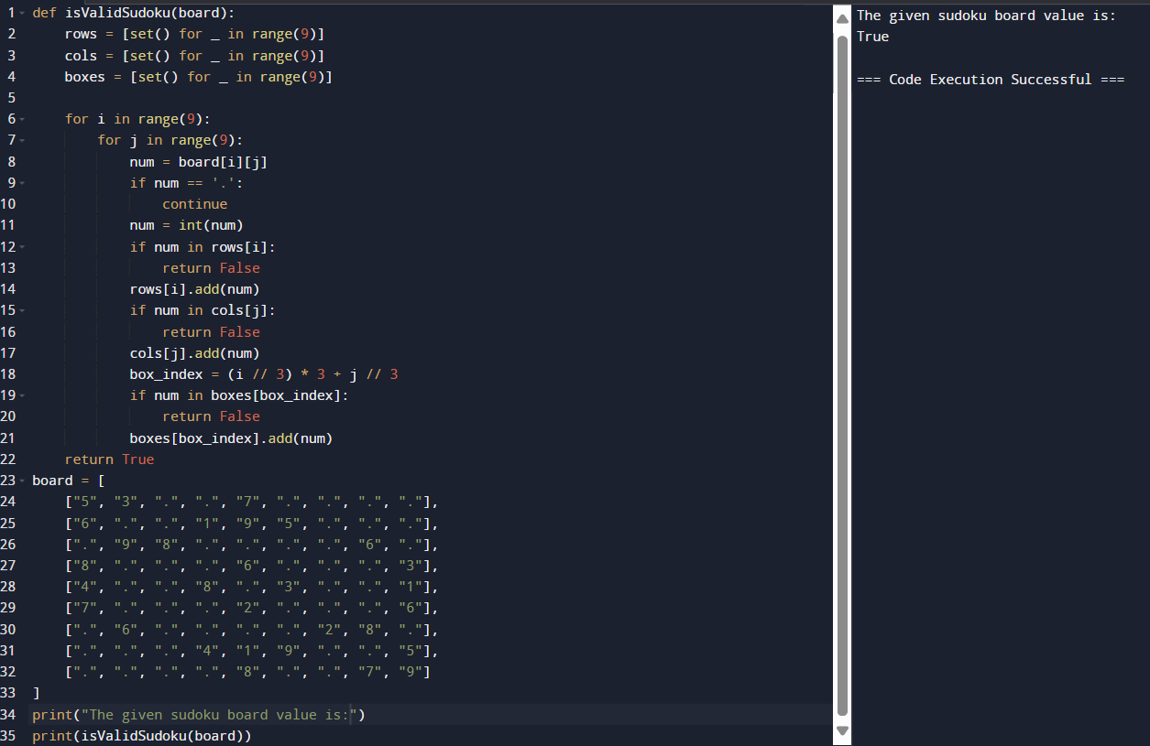

2.Sudoku Solver:

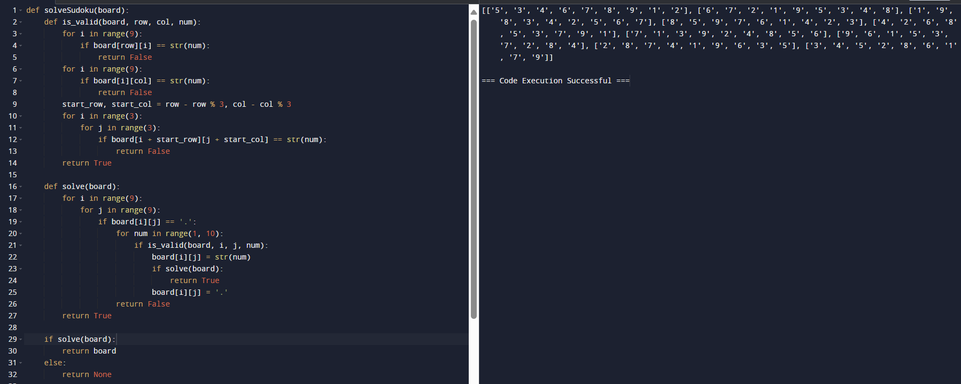

3.N-Queens I:

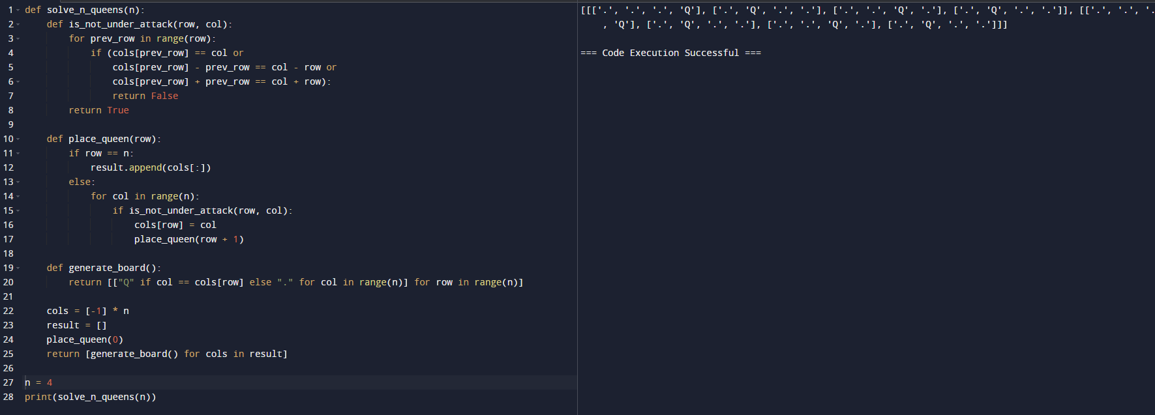

4.N-Queens II:

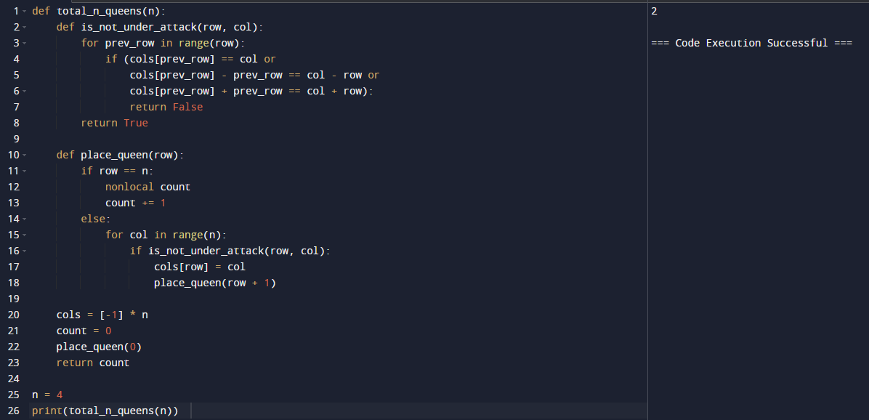

5.Subsets:

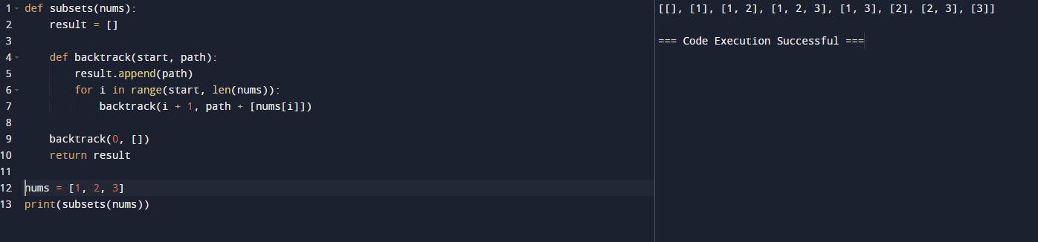

6.Longest Palindrome:

